**PYTHON ASSESMENT**

**PROBLEM 1** – Reverse a list in Python.

**SOLUTION 1(Using list indexing):**

Step 1 : Created a random list.

Step 2: printed the list using index as [starting index: ending index: step size].

**SOLUTION 2(Using reverse function):**

Step 1 : Created a random list.

Step 2: Applied the random function in the generated list and printed it.

**SOLUTION 3(Using For loops):**

Step 1 : Created a random list.

Step 2: Called for loops for every items inside the list, created a variable and store the last element of the list using POP() function.

Step 3: Used insert function for every element in list and inserted the last element.

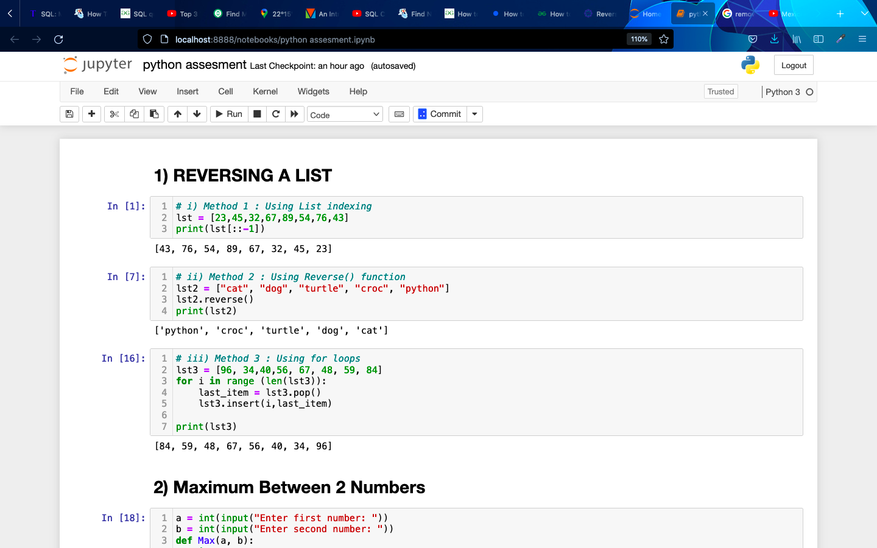

**PROBLEM 2** – Maximum Between 2 Numbers

**SOLUTION:**

Step 1: Taken inputs for 2 variables.

Step 2: Created a function with 2 arguments and implemented a if else clause that if first number is greater than the other than print first otherwise second.

Step 3: Called the function and printed it.

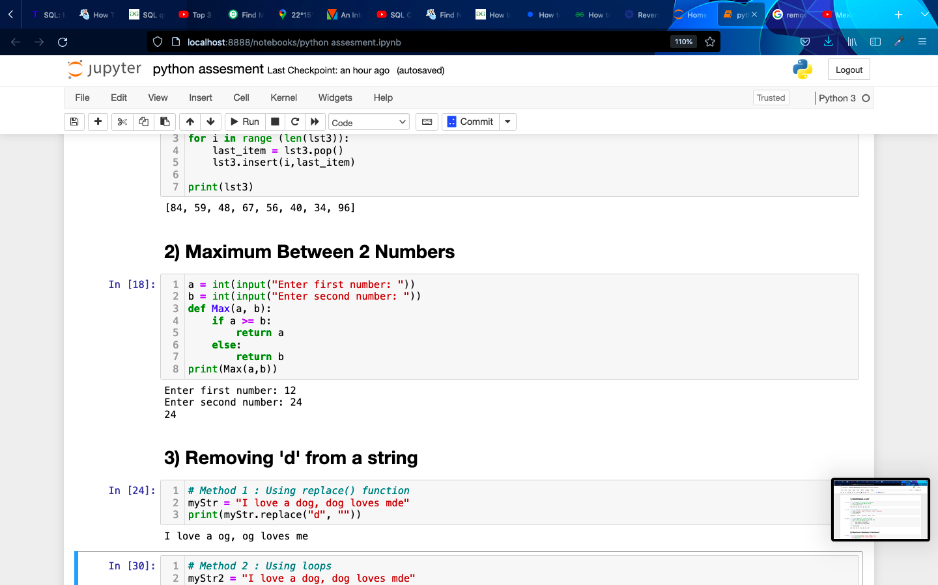

**PROBLEM 3** – Remove ‘d’ from a string.

**SOLUTION 1(Using replace function):**

Step 1: Created a string.

Step 2: Used replace function to replace ‘d’ by empty space and printed it

**SOLUTION 2(Using For loop):**

Step 1: Created a string.

Step 2: Created a new empty string.

Step 3: Used a for loop to iterate over the string, and set the parameters if i equals to “d”

Then ignore it, and store the result at new empty string and incremented it.

